**ER schema**

Entities, Attributes and Primary Keys

Restaurant (**resId**, resName, resPhone, -resLatitude, -resLongitude, -resAddress, -resPostalCode, resCostTwo, -rating5, -rating4, -rating3, -rating2, -rating1)

Cuisine (**cuisId**, cuisDescription)

Food Item (**foodId**, foodDescription, foodCalories)

Amenities (**amnId**, amnDescription)

**ER Diagram**

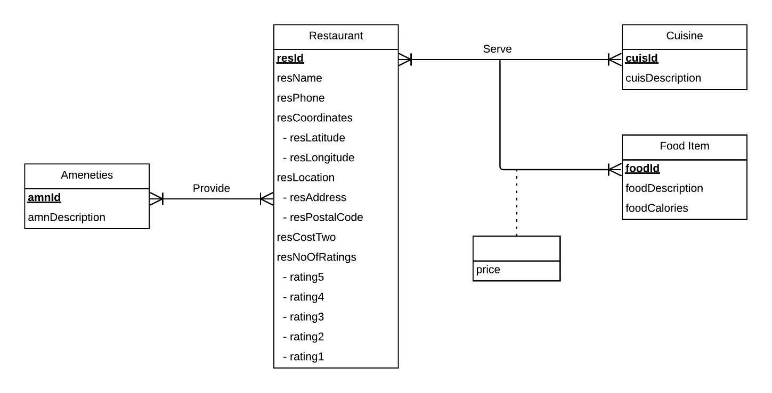

**Relations:**

Restaurant (**resId**, resName, resPhone, -resLatitude, -resLongitude, -resAddress, -resPostalCode, resCostTwo, -rating5, -rating4, -rating3, -rating2, -rating1)

Cuisine (**cuisId**, cuisDescription)

Food Item (**foodId**, foodDescription, foodCalories)

Amenities (**amnId**, amnDescription)

Serve (***resId, foodId*, *cuisId***,price)

Provide (***amnId, resId***)

**Functional Dependency:**

resId -> resName, resPhone, -resLatitude, -resLongitude, -resAddress, -resPostalCode, resCostTwo, -rating5, -rating4, -rating3, -rating2, -rating1

cuisId -> cuisDescription

foodId -> foodDescription, foodCalories

amnId -> amnDescription

resId, cuisId, foodId -> price

amnId, resId ->

**Normalization:**

Restaurant (**resId**, resName, resPhone, -resLatitude, -resLongitude, -resAddress, -resPostalCode, resCostTwo, -rating5, -rating4, -rating3, -rating2, -rating1) =3NF

Cuisine (**cuisId**, cuisDescription) = 3NF

Food Item (**foodId**, foodDescription, foodCalories) = 3NF

Amenities (**amnId**, amnDescription) = 3NF

Serve (***resId, foodId*, *cuisId****,* price) = 3NF

Provide (***amnId, resId***) = 3NF

**Business rules:**

1. When the amenities of a restaurant change, then the corresponding restaurant information must get updated
2. When the amenities of a restaurant are no longer there, then the corresponding restaurant information must get updated
3. When the restaurant information changes, then the corresponding amenity information should change
4. When a restaurant shuts down, then its corresponding amenity information is removed
5. When the restaurant shuts down, the corresponding cuisines and food items with that restaurant will get deleted
6. When the restaurant changes its name, information, phone number or location, the corresponding cuisines and food items with that restaurant will get updated
7. When the food item in a restaurant gets modified, then the corresponding cuisines in the restaurant must get updated
8. When the food item in a restaurant gets deleted, then the corresponding cuisines in the restaurant must get updated
9. When the cuisine in a restaurant changes, then the corresponding food items in the restaurant must change
10. When the cuisine in a restaurant gets deleted, then the corresponding food items in the restaurant must get updated

|  |  |  |  |  |  |  |  |
| --- | --- | --- | --- | --- | --- | --- | --- |
| Relation | Foreign Key | Base Relation | Primary Key | Business Rule | Constraint: ON DELETE | Business Rule | Constraint: ON UPDATE |
| Serve | resId | Restaurant | resId | R5 | CASCADE | R6 | CASCADE |
| Serve | cuisId | Cuisine | cuisId | R8 | CASCADE | R7 | CASCADE |
| Serve | foodId | Food Item | foodId | R10 | CASCADE | R9 | CASCADE |
| Provide | resId | Restaurant | resId | R4 | CASCADE | R3 | CASCADE |
| Provide | amnId | Amenities | amnId | R2 | CASCADE | R1 | CASCADE |